Operating system Introduction:

An Operating System (OS) acts as an interface connecting a computer user with the hardware of the computer. An operating system falls under the category of system software that performs all the fundamental tasks like file management, memory handling, process management, handling the input/output, and governing and managing the peripheral devices like disk drives, networking hardware, printers, etc.

# Features of Operating system:

• Memory Management

• Processor Managing

• Device Managing

. File handling

• Security Handling

• System performance controlling

• Job accounting and handling

What Is Linux?

Linux is an open-source operating system like other operating systems such as Microsoft Windows, Apple Mac OS, iOS, Google android, etc. An operating system is a software that enables the communication between computer hardware and software. It conveys input to get processed by the processor and brings output to the hardware to display it. This is the basic function of an operating system. Although it performs many other important tasks, let's not talk about that. Linux is around us since the mid-90s. It can be used from wristwatches to supercomputers. It is everywhere in our phones, laptops, PCs, cars and even in refrigerators. It is very much famous among developers and normal computer users.

## Evolution of Linux OS

• The Linux OS was developed by Linus Torvalds in 1991, which sprouted as an idea to improve the UNIX OS. He suggested improvements but was rejected by UNIX designers. Therefore, he thought of launching an OS, designed in a way that could be modified by its users.

• It is used from phones to supercomputers by almost all major hardware devices. Structure Of Linux Operating System An operating system is a collection of software, each designed for a specific function.

Linux OS has following components:

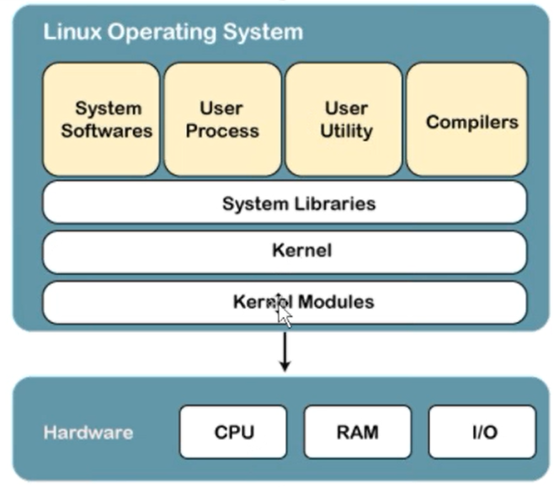

# Linux Kernel:

Linux kernel is the core part of the operating system. It establishes communication between devices and software. Moreover, it manages system resources. It has four Linux kernel is the core part of the operating system. It establishes communication between devices and software. Moreover, it manages system resources. It has four responsibilities:

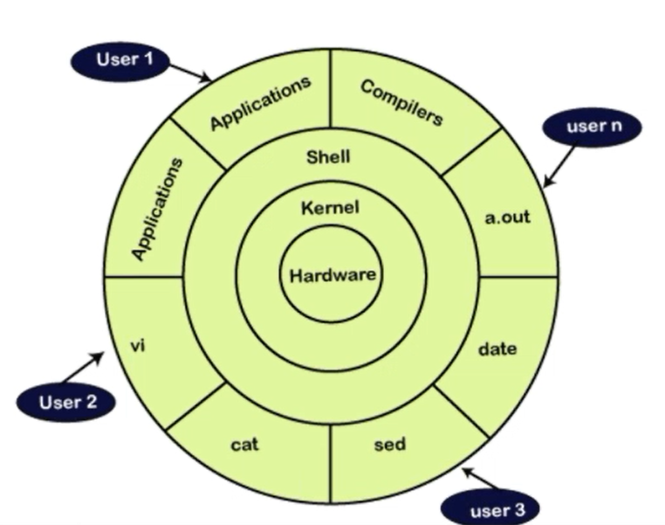

o device management: A system has many devices connected to it like CPU, a memory device, sound cards, graphic cards, etc. A kernel stores all the data related to all the devices in the device driver (without this kernel won't be able to control the devices). Thus kernel knows what a device can do and how to manipulate it to bring out the best performance. It also manages communication between all the devices. The kernel has certain rules that have to be followed by all the devices.

o Memory management: Another function that kernel has to manage is the memory management. The kernel keeps track of used and unused memory and makes sure that processes shouldn't manipulate data of each other using virtual memory addresses. o Process management: In the process, management kernel assigns enough time and gives priorities to processes before handling CPU to other processes. It also deals with security and ownership information.

o Handling system calls: Handling system calls means a programmer can write a query or ask the kernel to perform a task.

System Libraries

System libraries are special programs that help in accessing the kernel's features. A kernel has to be triggered to perform a task, and this triggering is done by the applications. But applications must know how to place a system call because each kernel has a different set of system calls. Programmers have developed a standard library of procedures to communicate with the kernel. Each operating system supports these standards, and then these are transferred to system calls for that operating system. The most well-known system library for Linux is Glibc (GNU C library).

3) System Tools

Linux OS has a set of utility tools, which are usually simple commands. It is a software which GNU project has written and publish under their open-source license so that software is freely available to everyone. With the help of commands, you can access your files, edit and manipulate data in your directories or files, change the location of files, or anything.

4) Development Tools

With the above three components, your OS is running and working. But to update your system, you have additional tools and libraries. These additional tools and libraries are written by the programmers and are called toolchain. A toolchain is a vital development tool used by the developers to produce a working application.

5) End User Tools

These end tools make a system unique for a user. End tools are not required for the operating system but are necessary for a user. Some examples of end tools are graphic design tools, office suites, browsers, multimedia players, etc.

Why use Linux?

This is one of the most asked questions about Linux systems. Why do we use a different and bit complex operating system, if we have a simple operating system like Windows? So, there are various features of Linux systems that make it completely different and one of the most used operating systems. Linux may be a perfect operating system if you want to get rid of viruses, malware, slowdowns, crashes, costly repairs, and many more. Further, it provides various advantages over another operating system, and we don't have to pay for it. Let's have a look at some of its special features that will attract you to switch your operating system.

* Free Open-source
* Secure Distributions
* Fast Performance

Free & Open Source

Operating System Most OS come in a compiled format means the main source code has run through a program called a compiler that translates the source code into a language that is known to the computer. Modifying this compiled code is a tough job. On the other hand, open-source is completely different. The source code is included with the compiled version and allows modification by anyone having some knowledge. It gives us the freedom to run the program, freedom to change the code according to our use, freedom to redistribute its copies, and freedom to distribute copies, which are modified by us. In short, Linux is an operating system that is "for the people, by the people." And we can dive in Linux without paying any cost. We can install it on Multiple machines without paying any cost.

It is secure

Linux supports various security options that will save you from viruses, malware, slowdowns, crashes. Further, it will keep your data protected. Its security feature is the main reason that it is the most favourable option for developers. It is not completely safe, but it is less vulnerable than others. Each application needs to authorize by the adminuser. The virus cannot be executed until the administrator provides the access password. Linux systems do not require any antivirus program.

# Favourable choice of Developers

Linux is suitable for the developers, as it supports almost all of the most used programming languages such as C/C++, Java, Python, Ruby, and more. Further, it facilitates with a vast range of useful applications for development. Developers find that the Linux terminal is much better than the Windows command line, So, they prefer terminal over the Windows command line. The package manager on Linux system helps programmers to understand how things are done. Bash scripting is also a functional feature for the programmers. Also, the SSH support helps to manage the servers quickly.

A flexible operating system

Linux is a flexible OS, as, it can be used for desktop applications, embedded systems, and server applications. It can be used from wristwatches to supercomputers. It is everywhere in our phones, laptops, PCs, cars and even in refrigerators. Further, it supports various customization options.

Linux Distributions

Many agencies modified the Linux operating system and makes their Linux distributions. There are many Linux distributions available in the market. It provides a different flavor of the Linux operating system to the users. We can choose any distribution according to our needs. Some popular distros are Ubuntu, Fedora, Debian, Linux Mint, Arch Linux, and many more. For the beginners, Ubuntu and Linux Mint are considered useful and, for the proficient developer, Debian and Fedora would be a good choice. To Get a list of distributions, visit Linux Distributions.

How does Linux work?

Linux is a UNIX-like operating system, but it supports a range of hardware devices from phones to supercomputers. Every Linux-based operating system has the Linux kernel and set of software packages to manage hardware resources. Also, Linux OS includes some core GNU tools to provide a way to manage the kernel resources, install software, configure the security setting and performance, and many more. All these tools are packaged together to make a functional operating system.

# Why is Linux better than other operating systems?

Following are top 20 advantages of the Linux operating system:

## 1. Open Source

As it is open-source, its source code is easily available. Anyone having programming knowledge can customize the operating system. One can contribute, modify, distribute, and enhance the code for any purpose.

## 2. Security

The Linux security feature is the main reason that it is the most favorable option for developers. It is not completely safe, but it is less vulnerable than others. Each application needs to authorize by the admin user. The virus is not executed until the administrator provides the access password. Linux systems do not require any antivirus program.

## 3. Free

Certainly, the biggest advantage of the Linux system is that it is free to use. We can easily download it, and there is no need to buy the license for it. It is distributed under GNU GPL (General Public License). Comparatively, we have to pay a huge amount for the license of the other operating systems.

## 4. Lightweight Linux is lightweight.

The requirements for running Linux are much less than other operating systems. In Linux, the memory footprint and disk space are also lower. Generally, most of the Linux distributions required as little as 128MB of RAM around the same amount for disk space.

## 5. stable

Linux is more stable than other operating systems. Linux does not require to reboot the system to maintain performance levels. It rarely hangs up or slow down. It has big up-times.

## 6. Performance

Linux system provides high performance over different networks. It is capable of handling a large number of users simultaneously.

7. Flexibility

Linux operating system is very flexible. It can be used for desktop applications, embedded systems, and server applications too. It also provides various restriction options for specific computers. We can install only necessary components for a system.

8. Software Updates

In Linux, the software updates are in user control. We can select the required updates. There a large number of system updates are available. These updates are much faster than other operating systems. So, the system updates can be installed easily without facing any issue.

9. Distributions/ Distros

There are many Linux distributions available in the market. It provides various options and flavours of Linux to the users. We can choose any distros according to our needs. Some popular distros are Ubuntu, Fedora, Debian, Linux Mint, Arch Linux, and many more.

10. Live CD/USB

Almost all Linux distributions have a Live CD/USB option. It allows us to try or run the Linux operating system without installing it.

11. Graphical User Interface

Linux is a command-line based OS but, it provides an interactive user interface like Windows.

12. Suitable for programmers

It supports almost all of the most used programming languages such as C/C++, Java, Python, Ruby, and more. Further, it offers a vast range of useful applications for development. The programmers prefer the Linux terminal over the Windows command line. The package manager on Linux system helps programmers to understand how things are done. Bash scripting is also a functional feature for the programmers. It also provides support for SSH, which helps in managing the servers quickly.

13. Community Support

Linux provides large community support. We can find support from various sources. There are many forums available on the web to assist users. Further, developers from the various opensource communities are ready to help us.

14. Privacy

Linux always takes care of user privacy as it never takes much private data from the user. Comparatively, other operating systems ask for the user's private data.

15. Networking

Linux facilitates with powerful support for networking. The client-server systems can be easily set to a Linux system. It provides various command-line tools such as ssh, ip mail, telnet, and more for connectivity with the other systems and servers. Tasks such as network backup are much faster than others.

16. Compatibility

Linux is compatible with a large number of file formats as it supports almost all file formats.

17. Installation

Linux installation process takes less time than other operating systems such as Windows. Further, its installation process is much easy as it requires less user input. It does not require much more system configuration even it can be easily installed on old machines having less configuration.

18. Multiple Desktop Support

Linux system provides multiple desktop environment support for its enhanced use. The desktop environment option can be selected during installation. We can select any desktop environment such as GNOME (GNU Network Object Model Environment) or KDE (K Desktop Environment) as both have their specific environment.

19. Multitasking

It is a multitasking operating system as it can run multiple tasks simultaneously without affecting the system speed.

20. Heavily Documented

for beginners There are many command-line options that provide documentation on commands, libraries, standards such as manual pages and info pages. Also, there are plenty of documents available on the internet in different formats, such as Linux tutorials, Linux documentation project, Server fault, and more. To help the beginners, several communities are available such as Ask Ubuntu, Reddit, and Stack Overflow.

# Linux Features

* Multiuser capability: Multiple users can access the same system resources like memory, hard disk, etc. But they have to use different terminals to operate.
* Multitasking: More than one function can be performed simultaneously by dividing the CPU time intelligently.
* Portability: Portability doesn't mean it is smaller in file size or can be carried in pen drives or memory cards. It means that it support different types of hardware.
* Security: It provides security in three ways namely authenticating (by assigning password and login ID), authorization (by assigning permission to read, write and execute) and encryption (converts file into an unreadable format).
* Live CD/USB: Almost all Linux distros provide live CD/USB so that users can run/try it without installing it.
* Graphical User Interface (X Window system): Linux is command line based OS but it can be converted to GUI based by installing packages. Support's customized keyboard: As it is used worldwide, hence supports different languages keyboards.
* Application support: It has its own software repository from where users can download and install many applications.
* File System: Provides hierarchical file system in which files and directories are arranged.
* Open Source: Linux code is freely available to all and is a community based development project.

# Why Use Linux

Linux is completely different from other operating systems in many ways.

* It is an open-source OS which gives a great advantage to the programmers as they can design their own custom operating systems.
* It gives you a lot of option of programs having some different features so you can choose according to your need.
* A global development community look at different ways to enhance its security, hence it is highly secured and robust so you don't need an anti-virus to scan it regularly. Companies like Google, Amazon and Facebook use Linux in order to protect their servers as it is highly reliable and stable.
* Above all you don't have to pay for software and server licensing to install Linux, its absolutely free and you can install it on as many computers as you want.
* It’s completely trouble-free operating system and don't have an issue with viruses, malware and slowing down your computer.